Figure 6

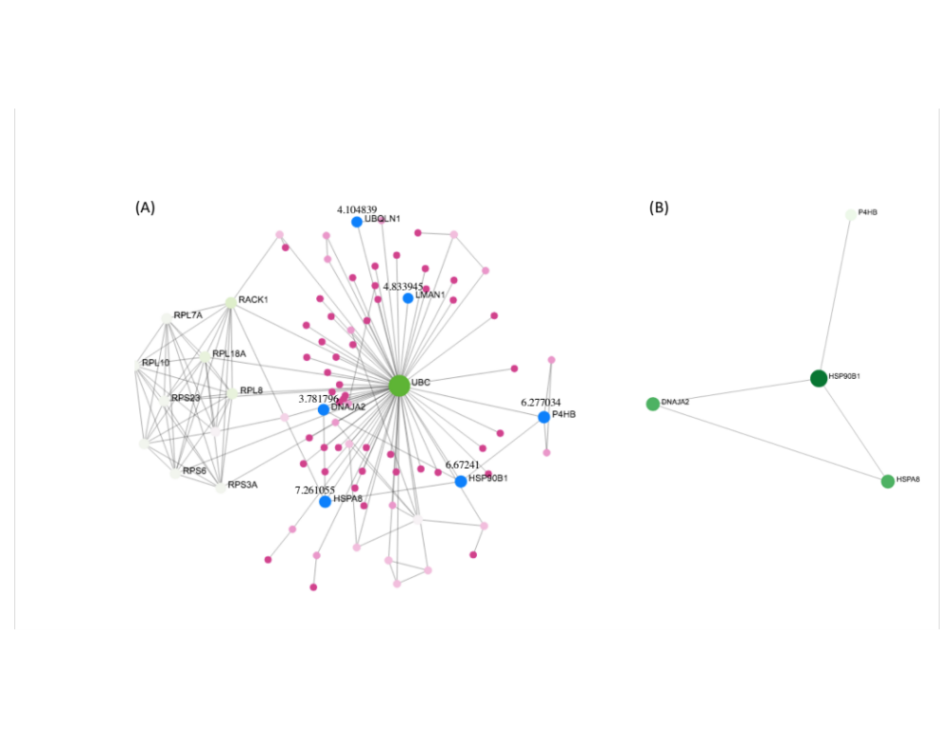
Figure 6. The PPI network of DEGs in PDAC tissues identified by NetworkAnalyst emphasizing the endoplasmic reticulum protein processing pathway associated genes are shown with “blue” nodes. (A) The numbers (bigger to slower) represent gene expression values of HSPA8, HSP90B1, P4HB, LMAN1, UBQLN1, and DNAJA2 respectively of subnetwork 1. (B) HPS gene family has the key genes HSP90B1 and HSPA8 of the subnetwork 2.

